Project Overview
This project explores how social media affects the way people behave and make buying decisions in the fashion industry. Over the last ten years, platforms such as Instagram, TikTok, Facebook, and YouTube have changed fashion marketing from traditional adverts to fast, interactive, and highly visual content.
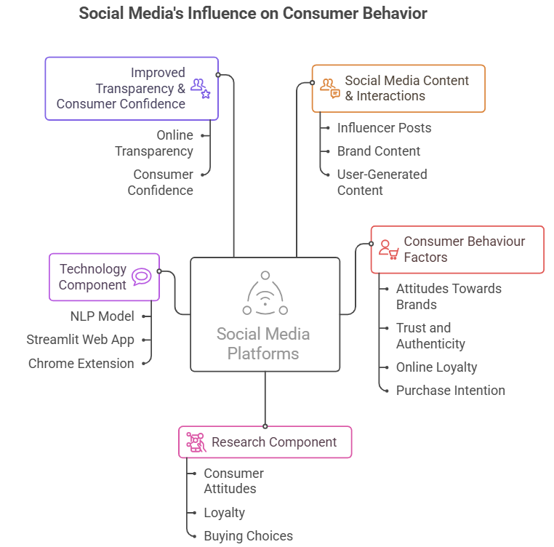
Even though fashion brands spend a lot of money on digital marketing, many still do not fully understand how online engagement leads to real purchases. This creates confusion when planning effective marketing strategies. This study aims to close that gap by looking at how social media posts, influencer trustworthiness, online interactions, and user-generated content shape consumers’ opinions, loyalty, and buying choices. In addition to the behavioural research, the project also builds a machine-learning system that detects fake online product reviews. This includes an NLP model, a Streamlit web application for instant predictions, and a Chrome extension for real-time review checking. The purpose of this research is to increase transparency and help consumers feel more confident when shopping online.

